Floating static route between office 1 and office 2 in case of static route failure for redundancy

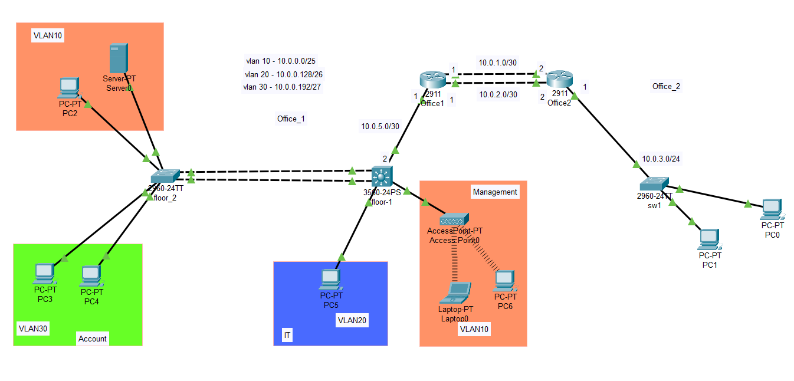

- Introduction

This lab demonstrates the configuration of a multi-office and multi-floor enterprise network. The design integrates redundancy, inter-VLAN routing, DHCP services, NAT translation, and connectivity between different offices and floors. The network ensures high availability and scalability by implementing Layer 2 EtherChannel, static and floating static routes, and DHCP servers distributed across different offices.
- Configure IP addressing for all devices and interfaces to ensure proper subnetting and connectivity.
- Implement static routing between Office 1 and Office 2 using the 10.0.1.0/30 link as the primary path.
- Configure a floating static route using the 10.0.2.0/30 link with an increased Administrative Distance (AD +10) for redundancy.
- Create a Layer 2 EtherChannel between Floor 1 and Floor 2 switches to provide aggregated bandwidth and redundancy.
- Implement inter-VLAN routing on the Floor 1 router for VLANs 10, 20, and 30 to allow communication between departments.
- Configure DHCP services where:
  - Office 1 provides dynamic IP addressing for VLAN 10.
  - Office 2 provides dynamic IP addressing for Switch 1 hosts.
- Set up Dynamic NAT in Office 2 to translate internal private IP addresses into public IPs for Internet access.
- Verify connectivity between VLANs, across offices, and with external networks, ensuring that redundancy and NAT translation work correctly.
This step-by-step configuration ensures that:
- Redundancy is maintained with static and floating routes.
- Bandwidth and fault tolerance are improved using EtherChannel.
- VLANs are properly segmented but still able to communicate via inter-VLAN routing.
- DHCP is centralized in Office 1 and Office 2 for efficient address management.
- Internal users can access external services through NAT.

Device / Interface | IP Address | Subnet Mask
Floor-1 L3-SW (3560) VLAN10 | 10.0.0.1 | 255.255.255.128 (/25)
Floor-1 L3-SW (3560) VLAN20 | 10.0.0.129 | 255.255.255.192 (/26)
Floor-1 L3-SW (3560) VLAN30 | 10.0.0.193 | 255.255.255.224 (/27)
Floor-1 L3-SW Gi0/1 (to Office1) | 10.0.5.2 | 255.255.255.252 (/30)
Router R1 Gi0/0 (to Floor-1) | 10.0.5.1 | 255.255.255.252 (/30)
Router R1 g0/1 (to R2, Primary) | 10.0.1.1 | 255.255.255.252 (/30)
Router R1 g0/2(to R2, Backup) | 10.0.2.1 | 255.255.255.252 (/30)
Router R2 g0/1(to R1, Primary) | 10.0.1.2 | 255.255.255.252 (/30)
Router R2 g0/2(to R1, Backup) | 10.0.2.2 | 255.255.255.252 (/30)
Router R2 Gi0/0 (to SW1 LAN) | 10.0.3.1 | 255.255.255.0 (/24)
SW1 Default Gateway | 10.0.3.1 | 255.255.255.0 (/24)
PCs VLAN10 (e.g., PC2, Laptop) | DHCP | 255.255.255.128 (/25)
PCs VLAN20 (e.g., PC5) | Static 10.0.0.130 | 255.255.255.192 (/26)
PCs VLAN30 (e.g., PC3, PC4) | Static  10.0.0.194,10.0.0.195 | 255.255.255.224 (/27)
PCs in Office_2 (SW1 LAN) | DHCP | 255.255.255.0 (/24)

2. Configure Floor-1 L3 Switch (SVIs, Inter-VLAN, routed uplink, default route)
In the Floor-1 Layer-3 switch I will enable ip routing, create SVIs for VLANs 10/20/30, and assign their gateway IPs (10.0.0.1/25, 10.0.0.129/26, 10.0.0.193/27). I will configure the uplink to R1 as a routed port with 10.0.0.225/30. To allow VLAN 10 hosts to get addresses from R1, I will add an IP helper on SVI VLAN 10 pointing to 10.0.0.226. Finally, I will set a default route on the L3 switch to 10.0.0.226 so all non-local traffic goes to R1.
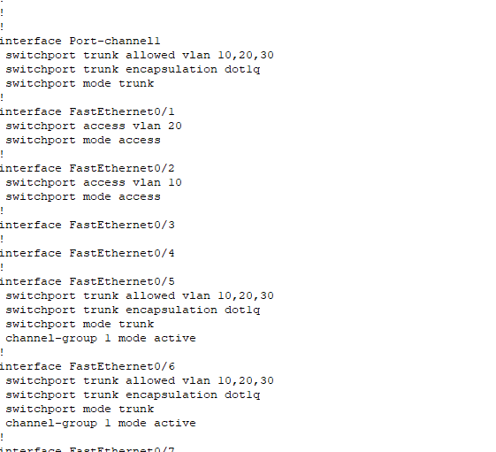
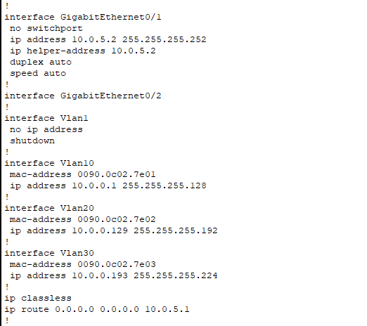

3. Build Layer-2 EtherChannel (LACP) between Floor-1 and Floor-2
Between Floor-1 (core) and Floor-2 (access) switches I will bundle the two uplinks using LACP into Port-Channel 1. I will make the port-channel a trunk and allow VLANs 10, 20, and 30. On Floor-2 I will keep user ports as access in the correct VLANs. This gives higher bandwidth and rapid failover at L2 without STP blocking.
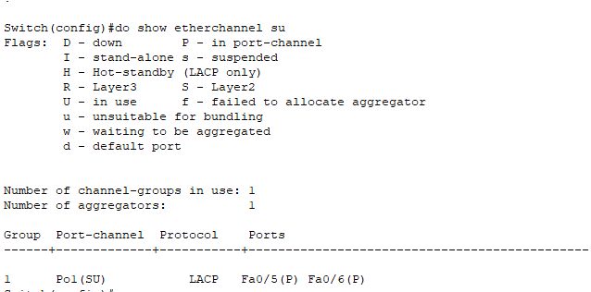
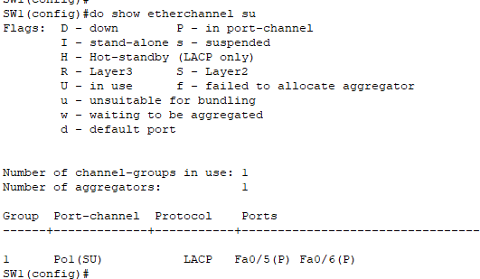

4. Configure floor 1 , DHCP for VLAN 10, and routes
Assign 10.0.0.226/30 to the LAN interface toward the L3 switch, 10.0.1.1/30 to the primary WAN serial, and 10.0.2.1/30 to the backup WAN serial. I will configure DHCP for VLAN 10 with the pool 10.0.0.0/25, gateway 10.0.0.1, DNS, and appropriate exclusions. For routing,

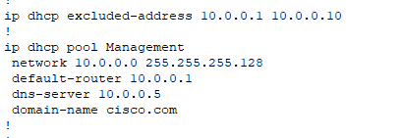

5. Configure Office_2 Router (R2): Interfaces, DHCP for Office_2 LAN, Dynamic NAT, and routes
In R2 I will set 10.0.3.1/24 on the LAN interface (marked NAT inside) and assign 10.0.1.2/30 (primary) and 10.0.2.2/30 (backup) to the WAN serials (marked NAT outside). I will configure DHCP for the Office_2 LAN (10.0.3.0/24) so SW1’s hosts get automatic addressing. I will implement Dynamic PAT (NAT overload) so 10.0.3.0/24 is translated to whichever WAN interface is used by the route (primary or backup). For routing back to Office_1, I will add a primary static route to 10.0.0.0/24 via 10.0.1.1 and a floating static via 10.0.2.1 with AD 10 to maintain redundancy.

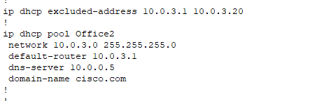

6. Configure Office_2 Switch (SW1): Access ports and default gateway
In SW1 I will place user-facing ports into the appropriate access VLAN (as per your device placements) and set the default gateway to 10.0.3.1 (R2). This lets the switch itself and connected hosts reach devices beyond the local subnet.

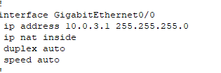

7. Static Route and Floating Static route verification
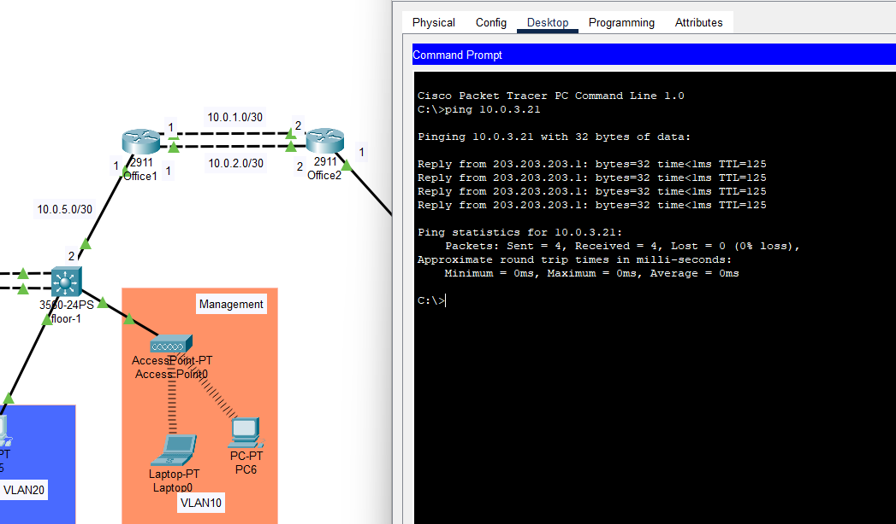
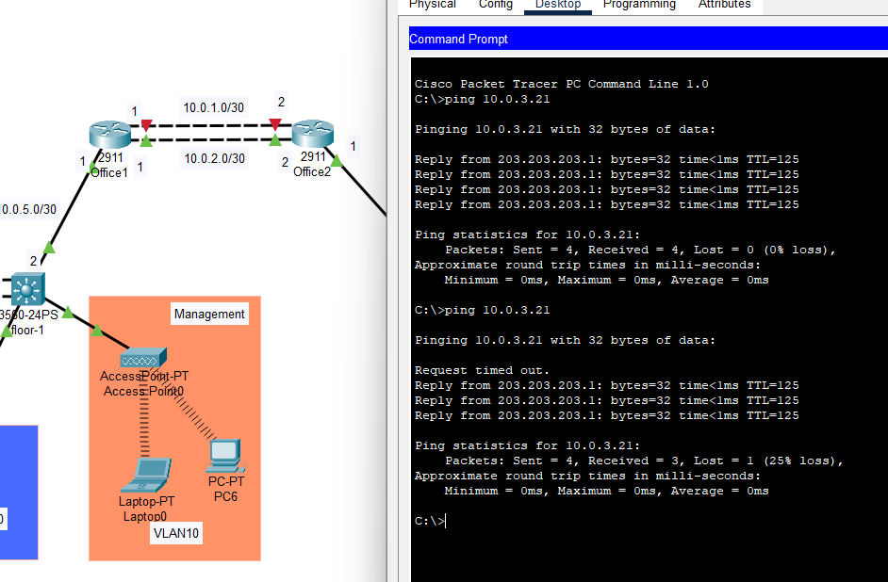

8. Verify Inter-VLAN, site-to-site routing, DHCP, and NAT
In this step I will verify end-to-end operation. From VLAN 10/20/30 hosts at Office_1 I will confirm they receive DHCP (VLAN 10) and can ping across VLANs (Inter-VLAN routing). I will test Office_1 ↔ Office_2 reachability (e.g., ping 10.0.3.1 from VLAN 10 and vice versa). On R2 I will check NAT translations while generating traffic from a 10.0.3.x host to outside networks. Finally, I will simulate a failure by shutting the primary WAN and confirm traffic automatically reroutes via the floating static (AD 10), then restore the link to see the primary path preferred again.

